**PRAKTIKUM 2**

**NAMA : SUGIONO**

**NIM : 18090063**

**KELAS : 5A D4 TEKNIK INFORMATIKA**

**MK : WEB PROGRAMMING 2**

View-latihan 1

*URL : <http://localhost/pustaka_sugiono/index.php/latihan1>*

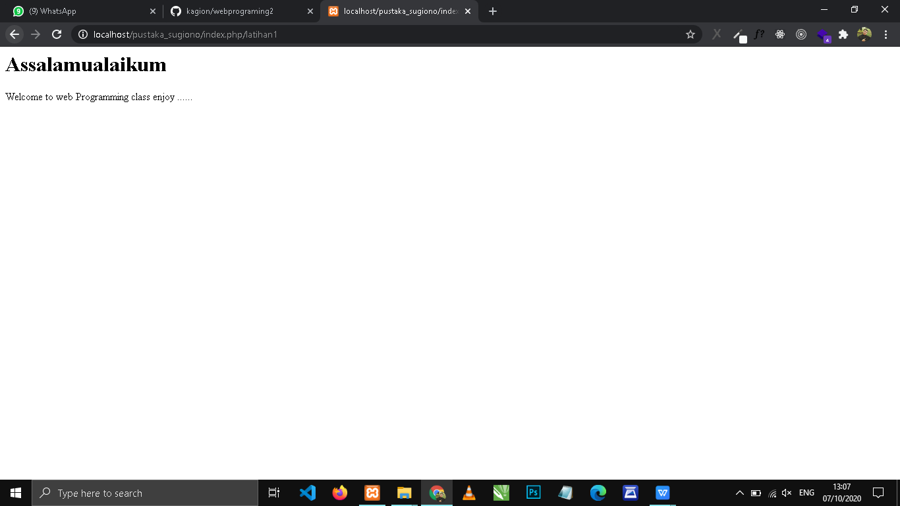

*URL : <http://localhost/pustaka_sugiono/index.php/latihan1/penjumlahan/2/3>*

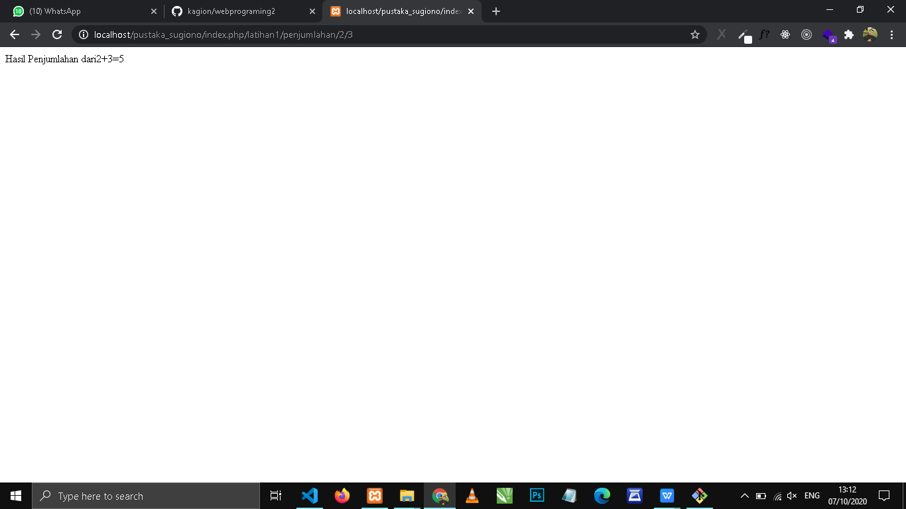

LATIHAN2

*URL : <http://localhost/pustaka_sugiono/index.php/latihan2/Penjumlahan/10/10>*

